Peer Review Allocation System
Day 1 Deliverable – Database Design
Prepared By
Database Engineer (Member 3)

1. Introduction
The Peer Review Allocation System requires a structured database to manage students, teams, assignment submissions, reviewer allocations, and review history. The database design aims to support all project constraints while ensuring fair reviewer distribution, conflict prevention, and efficient tracking of review activities.
The proposed database follows a relational model and is designed for implementation using PostgreSQL and Prisma ORM.

2. Objectives
The database is designed to support the following requirements:
- Store student and team information.
- Manage assignment submissions.
- Track reviewer assignments.
- Prevent self-review and same-team reviews.
- Maintain reviewer-reviewee history.
- Support workload balancing and fairness metrics.

3. Core Entities
The following entities have been identified from the project requirements:
Student
Stores information about students participating in the peer review process.
Team
Stores team information used for conflict checking.
Submission
Stores assignment submissions uploaded by students.
ReviewTask
Stores reviewer assignments generated by the allocation algorithm.
PairHistory
Maintains historical reviewer-reviewee relationships to avoid repeated pairings.

4. Entity Relationship Diagram (ER Diagram)
Figure 1: ER Diagram for Peer Review Allocation System

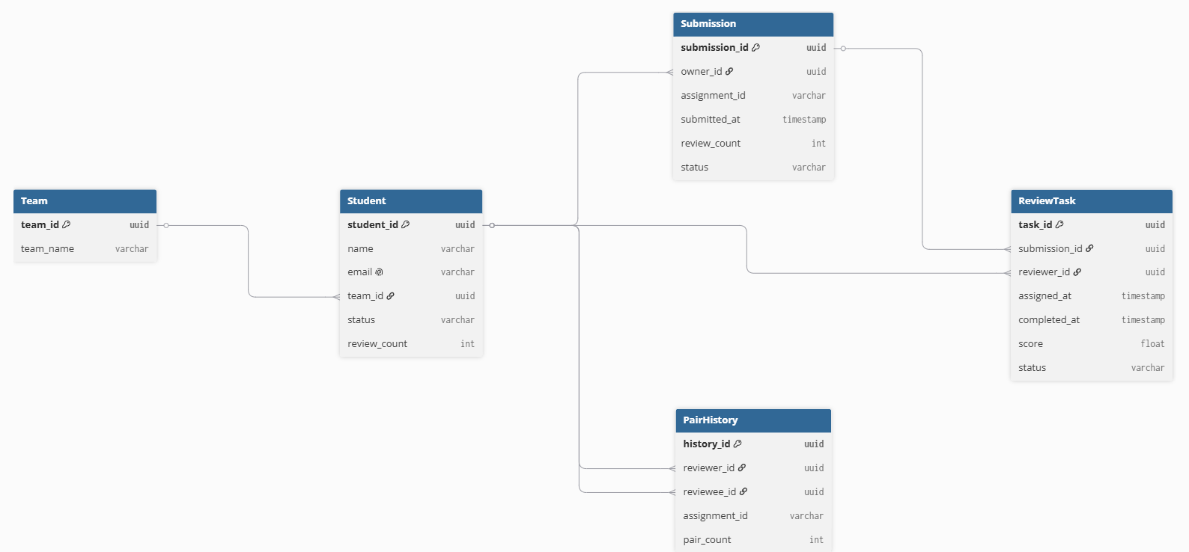

5. Entity Description
5.1 Student
Attribute | Description
student_id | Unique student identifier
name | Student name
email | Student email address
team_id | Associated team
status | Active or inactive status
review_count | Number of reviews assigned
Purpose:
- Identifies eligible reviewers.
- Supports workload balancing.
- Maintains student information.

5.2 Team
Attribute | Description
team_id | Unique team identifier
team_name | Team name
Purpose:
- Supports same-team conflict prevention.

5.3 Submission
Attribute | Description
submission_id | Unique submission identifier
owner_id | Student who submitted
assignment_id | Assignment reference
submitted_at | Submission timestamp
review_count | Number of reviews received
status | Current submission status
Purpose:
- Stores assignment submissions.
- Tracks review progress.

5.4 ReviewTask
Attribute | Description
task_id | Unique review task identifier
submission_id | Submission under review
reviewer_id | Assigned reviewer
assigned_at | Assignment timestamp
completed_at | Completion timestamp
score | Review score
status | Review status
Purpose:
- Manages reviewer assignments.
- Tracks review completion.

5.5 PairHistory
Attribute | Description
history_id | Unique record identifier
reviewer_id | Reviewer identifier
reviewee_id | Reviewee identifier
assignment_id | Assignment reference
pair_count | Number of previous interactions
Purpose:
- Prevents repeated reviewer-reviewee pairings.
- Supports fairness optimization.

6. Relationship Summary
The database follows the relationships below:
- One Team can contain multiple Students.
- One Student can create multiple Submissions.
- One Submission can receive multiple Review Tasks.
- One Student can perform multiple Review Tasks.
- One Student can appear in multiple Pair History records.
Relationship Overview:
Team (1) → Many Students
Student (1) → Many Submissions
Submission (1) → Many ReviewTasks
Student (1) → Many ReviewTasks
Student (1) → Many PairHistory Records

7. Constraint Mapping
Constraint | Database Support
No Self Review | reviewer_id ≠ owner_id
No Same Team Review | team_id validation
Minimum Two Reviews Per Submission | review_count tracking
No Duplicate Review Assignment | Unique reviewer-submission mapping
Active Reviewers Only | status validation

8. Proposed Technology Stack
Database: PostgreSQL
ORM: Prisma ORM
Reasons:
- Strong relational support
- Foreign key constraints
- ACID-compliant transactions
- Easy integration with Node.js and TypeScript
- Industry-standard database solution

9. Conclusion
The database design phase has been successfully completed. Five core entities were identified and their relationships were defined. The schema supports all project constraints including conflict prevention, fairness tracking, and review allocation management.

